PaperSHREC 2022: Fitting and recognition of simple geometric primitives on point clouds — A Deep Learning based method
Yifan Qie*, Nabil Anwer
Université Paris-Saclay, ENS Paris-Saclay, LURPA, 91190, Gif-sur-Yvette, France
* Corresponding author. E-mail address: yifan.qie@ens-paris-saclay.fr
Abstract The aim of this SHREC track is to evaluate the quality of automatic algorithms for fitting and recognising geometric primitives in point clouds. The goal is to identify, for each point cloud, its primitive type and some geometric descriptors. The proposed method is based on Deep learning techniques. The classical surface primitives derived from constructive solid geometry, including planes, spheres, cylinders, cones and tori, are pre-processed into images as input for training a neural network. Transfer learning based on AexNet is used in this paper for training an image set that contains 46000 data. After about 5 hours training by 6 epochs, the prediction accuracy is about 87%. The pre-trained NN is then used for the test set and different fitting algorithms are implemented for each type of primitives. The fitting result can be generated for each model within a second.
Keywords: Deep transfer learning; least square fitting
Information
The training process is shown in Figure 1. The execution time for each model of the test set is about 0.5 second on average.
Some of the fitting results are shown in Figure 2. All tests are performed on a workstation equipped with a 1.70 GHz Intel(R) Xeon(R) CPU, an 16 GB RAM, and the Windows 10 operating system. Github link of the code will be released soon.

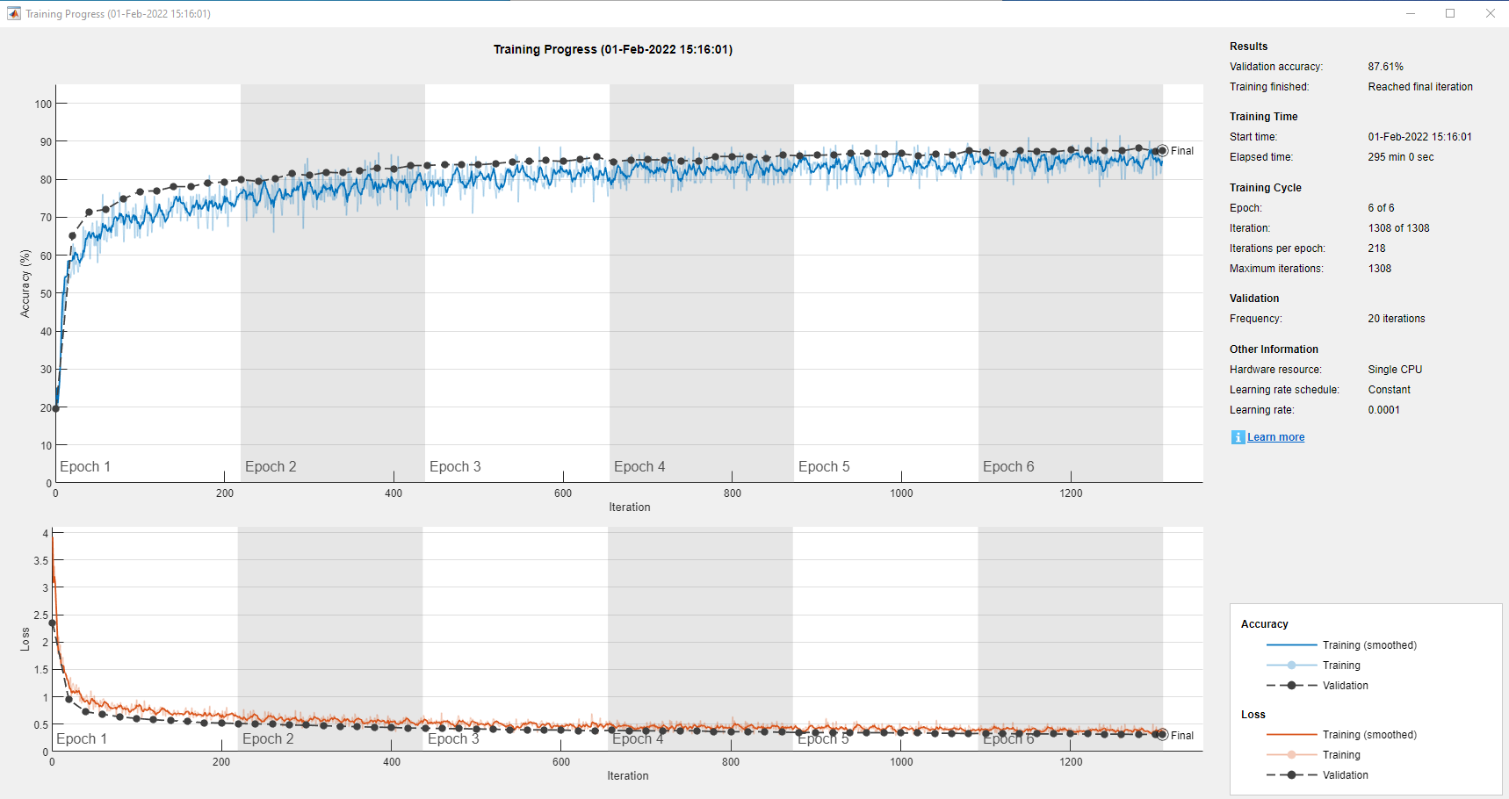
Fig. 1. Training time: 295 min
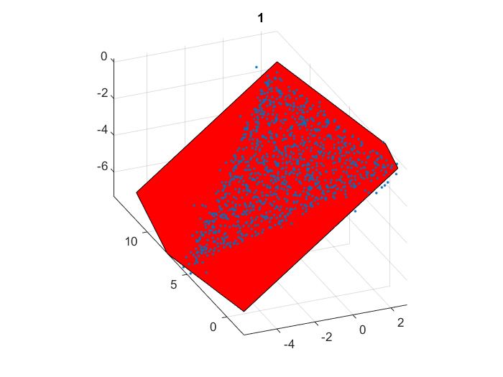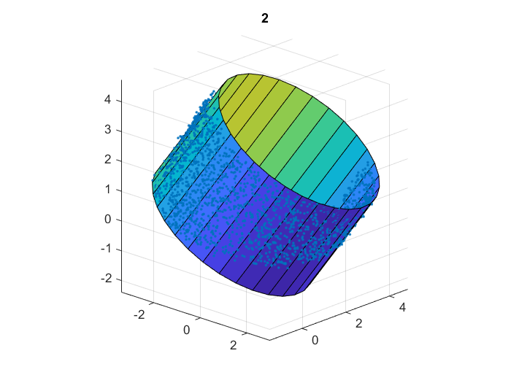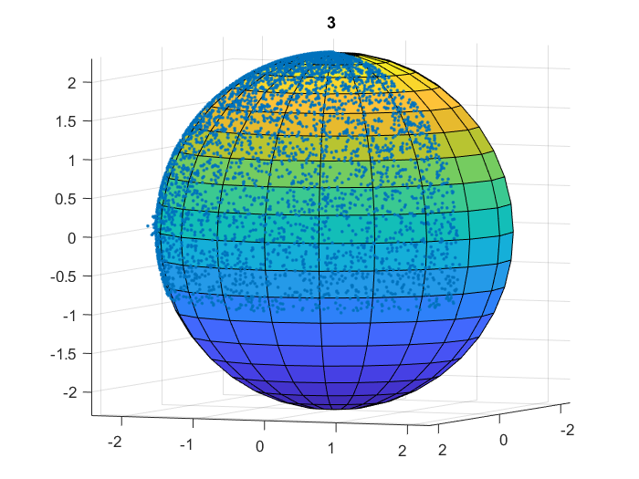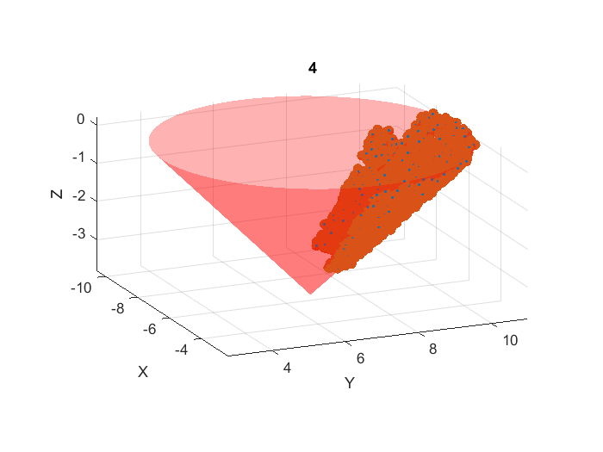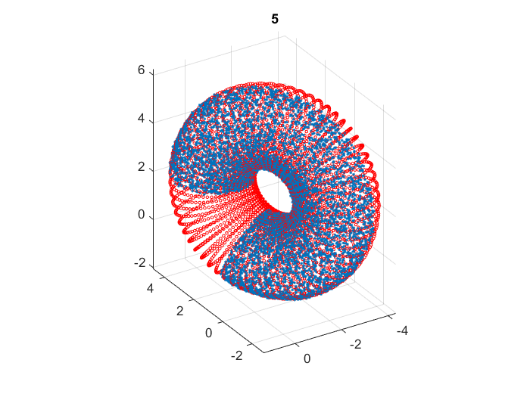
Fig. 2. Fitting results.

